**User Manual: Multimodal LLM Road Safety Platform**

Table of Contents

1. INTRODUCTION 3

2. ACCESSING THE APPLICATION 3

3. SYSTEM REQUIRMENTS 3

4. INSTALLATION AND SETUP 3

5. USING THE APPLICATION 4

4.1 Sidebar Settings 4

4.2 Single Image Analysis 4

4.3 Bulk Image Analysis 5

6. FEATURES 5

7. TROUBLESHOOTING 5

8. FAQS 5

# **1. INTRODUCTION**

The Multimodal LLM Road Safety Platform is an advanced tool designed to analyze road safety images using artificial intelligence, specifically Google's Gemini 1.5 Flash AI model. It provides insights on potential hazards, safety features, and suggestions for improvements in road safety scenarios.

# **2. ACCESSING THE APPLICATION**

The Multimodal LLM Road Safety Platform is deployed and accessible online at:

<https://llmroadsafetyplatform.streamlit.app/>

You can use this link to access the application directly without any local setup. Simply open the link in your web browser to start using the platform.

# **3. SYSTEM REQUIRMENTS**

* Python 3.7 or higher
* Modern web browser (Chrome, Firefox, Safari, or Edge)
* Internet connection
* Gemini API key (obtainable from [Google AI Studio](https://aistudio.google.com/app/apikey))

# **4. INSTALLATION AND SETUP**

**1. Clone the repository:**

```

git clone https://github.com/AlteredOracle/CITS5206.git

cd CITS5206

```

**2. (Optional but recommended) Set up a virtual environment:**

```

python -m venv venv

source venv/bin/activate # On Windows use `venv\Scripts\activate`

```

**3. Install the required dependencies:**

```

pip install -r requirements.txt

```

**4. Run the Streamlit app:**

```

streamlit run src/app.py

```

**5.** Open a web browser and navigate to the URL provided by Streamlit (usually `http://localhost:8501`).

**6.** When you first open the application, you'll be prompted to enter your Gemini API key. Enter it in the designated field.

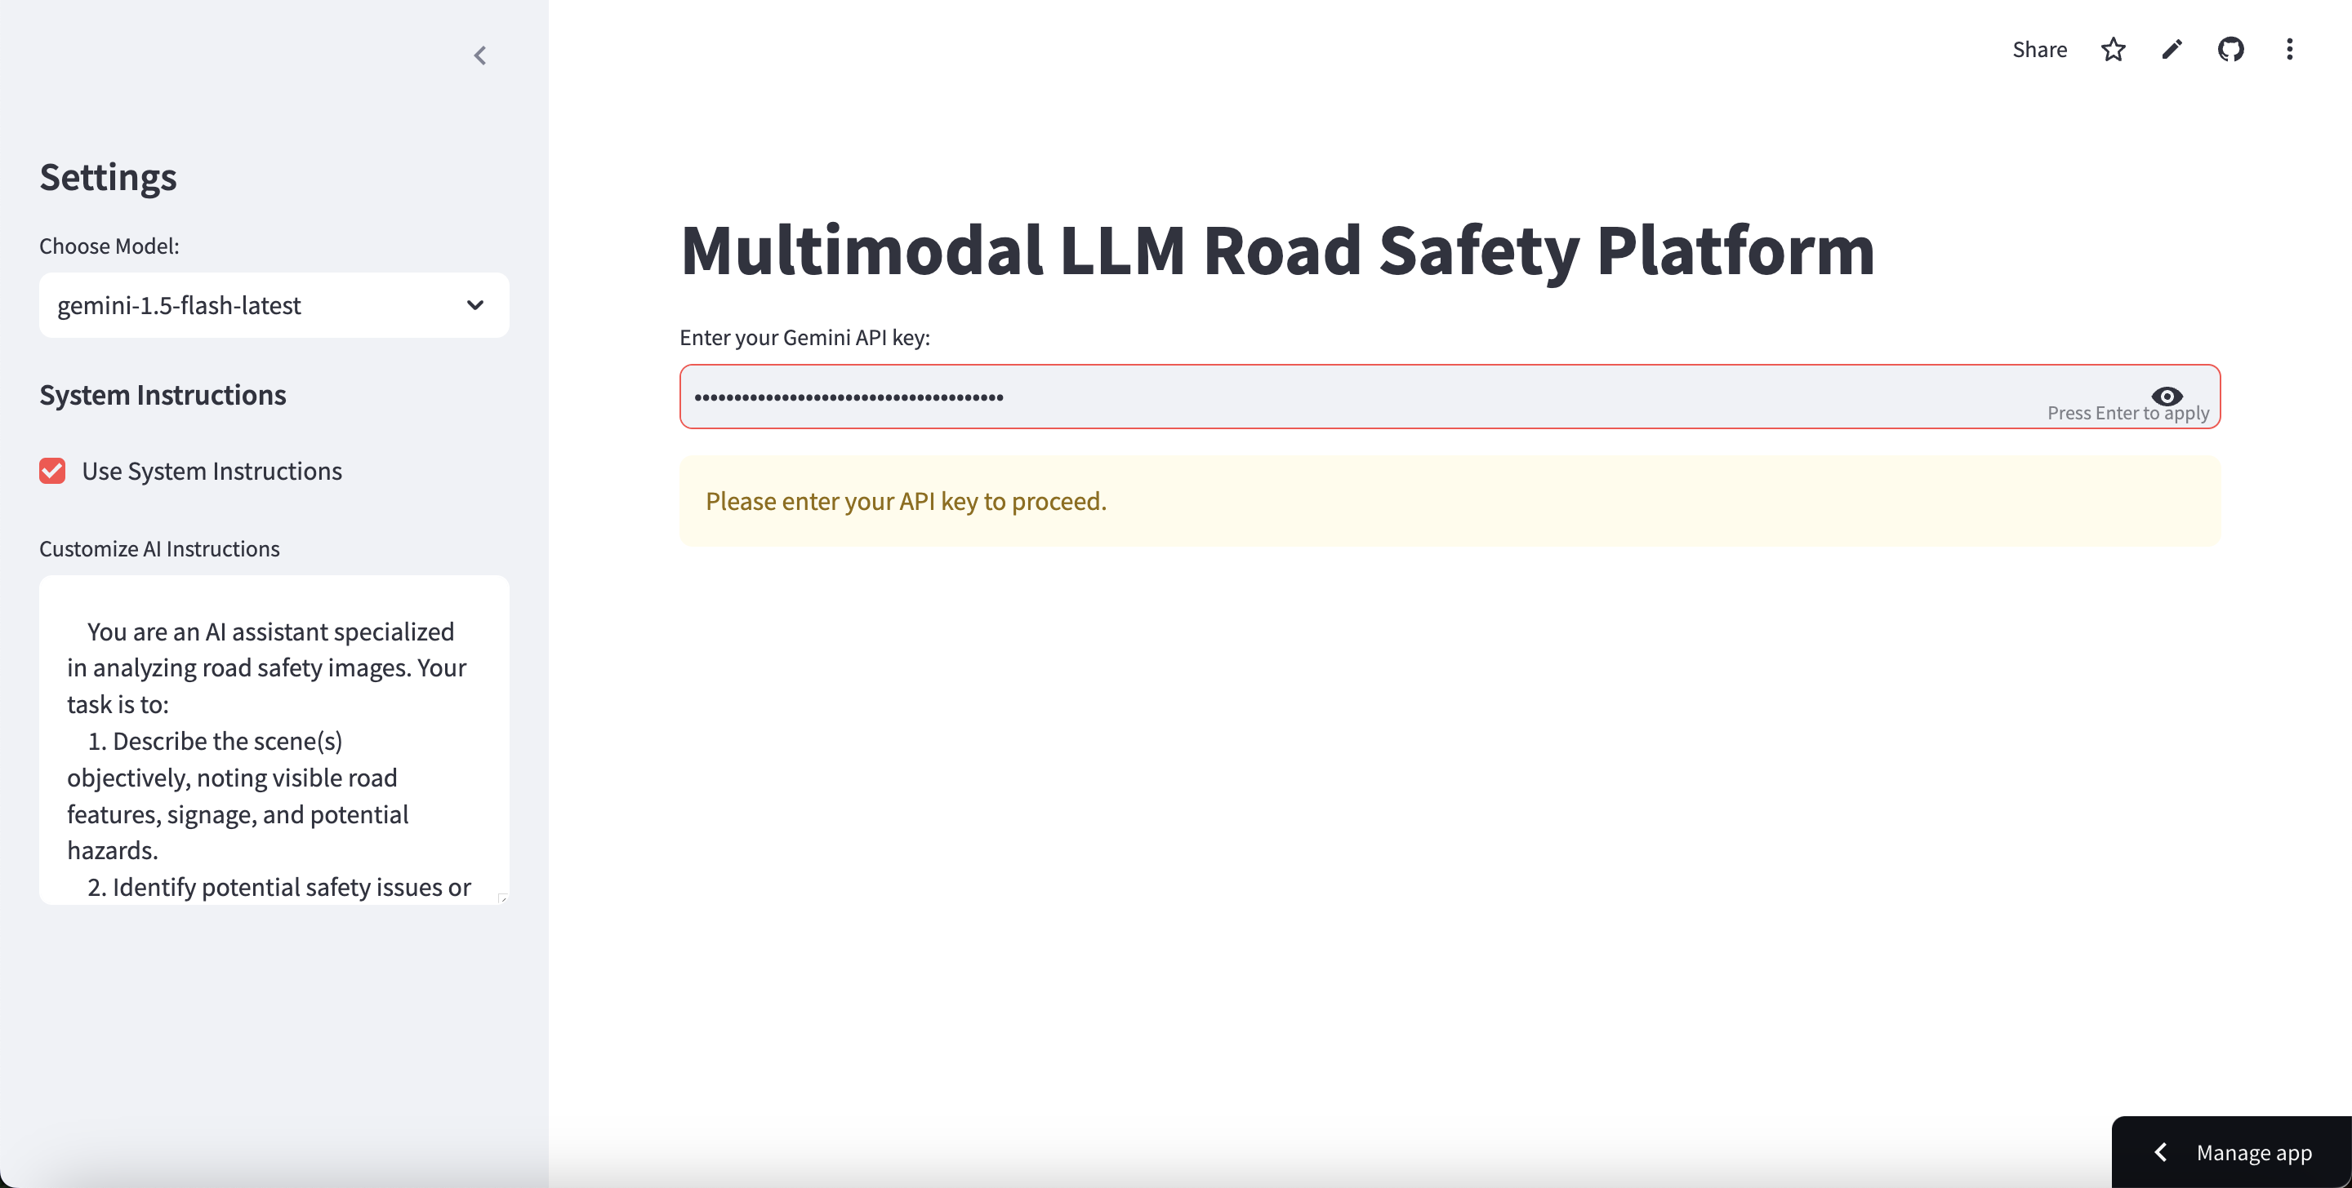

# **5. USING THE APPLICATION**

## 4.1 Sidebar Settings

**1. Model Selection:** Choose between "gemini-1.5-flash-latest" and "gemini-1.5-pro"

**2. System Instructions:** Toggle on/off and customize the AI's analysis instructions

**3. Analysis Mode:** Select between "Single" and "Bulk" analysis

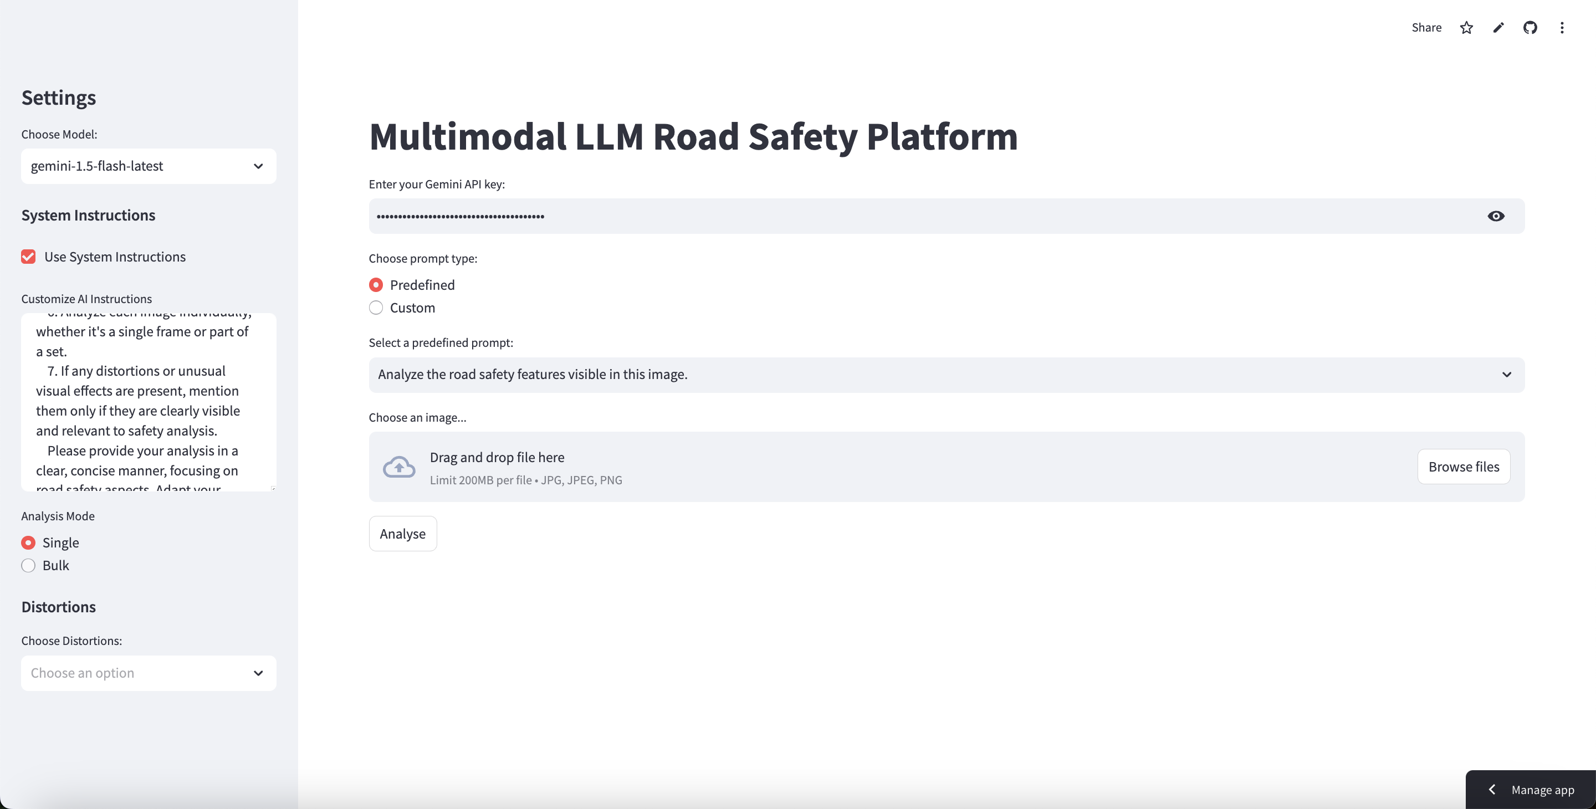

## 4.2 Single Image Analysis

**1.** Upload an image using the file uploader

**2.** (Optional) Apply distortions to the image:

- Select distortion types from the dropdown

- Adjust intensity sliders for each distortion

**3.** Enter your analysis prompt or select a predefined prompt

**4.** Click "Analyze Image" to generate the AI response

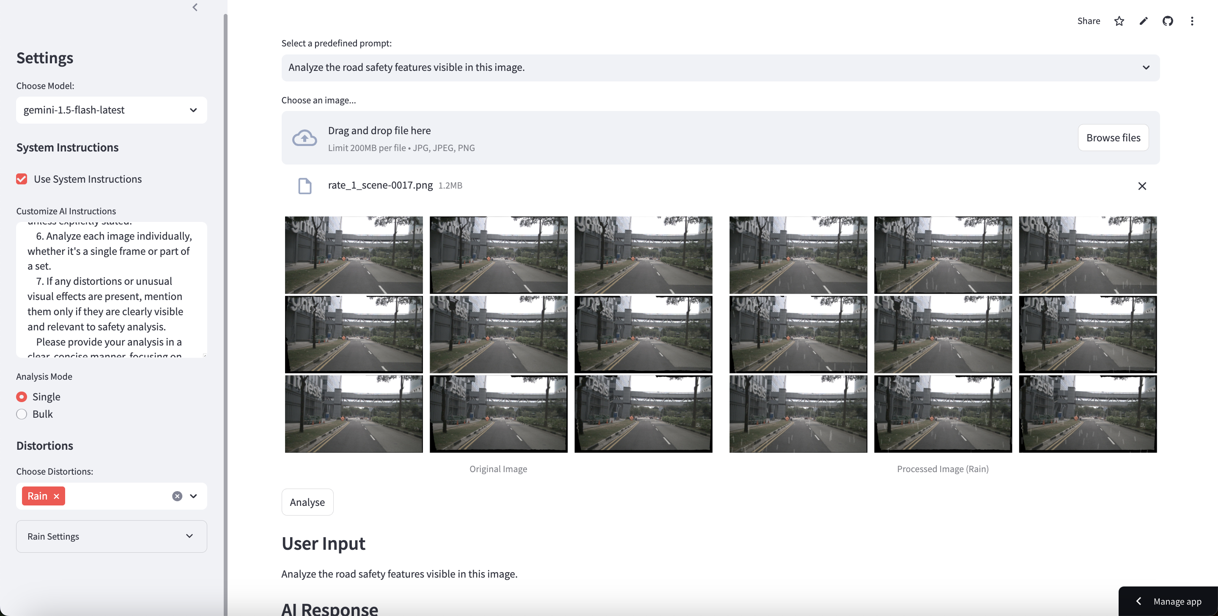

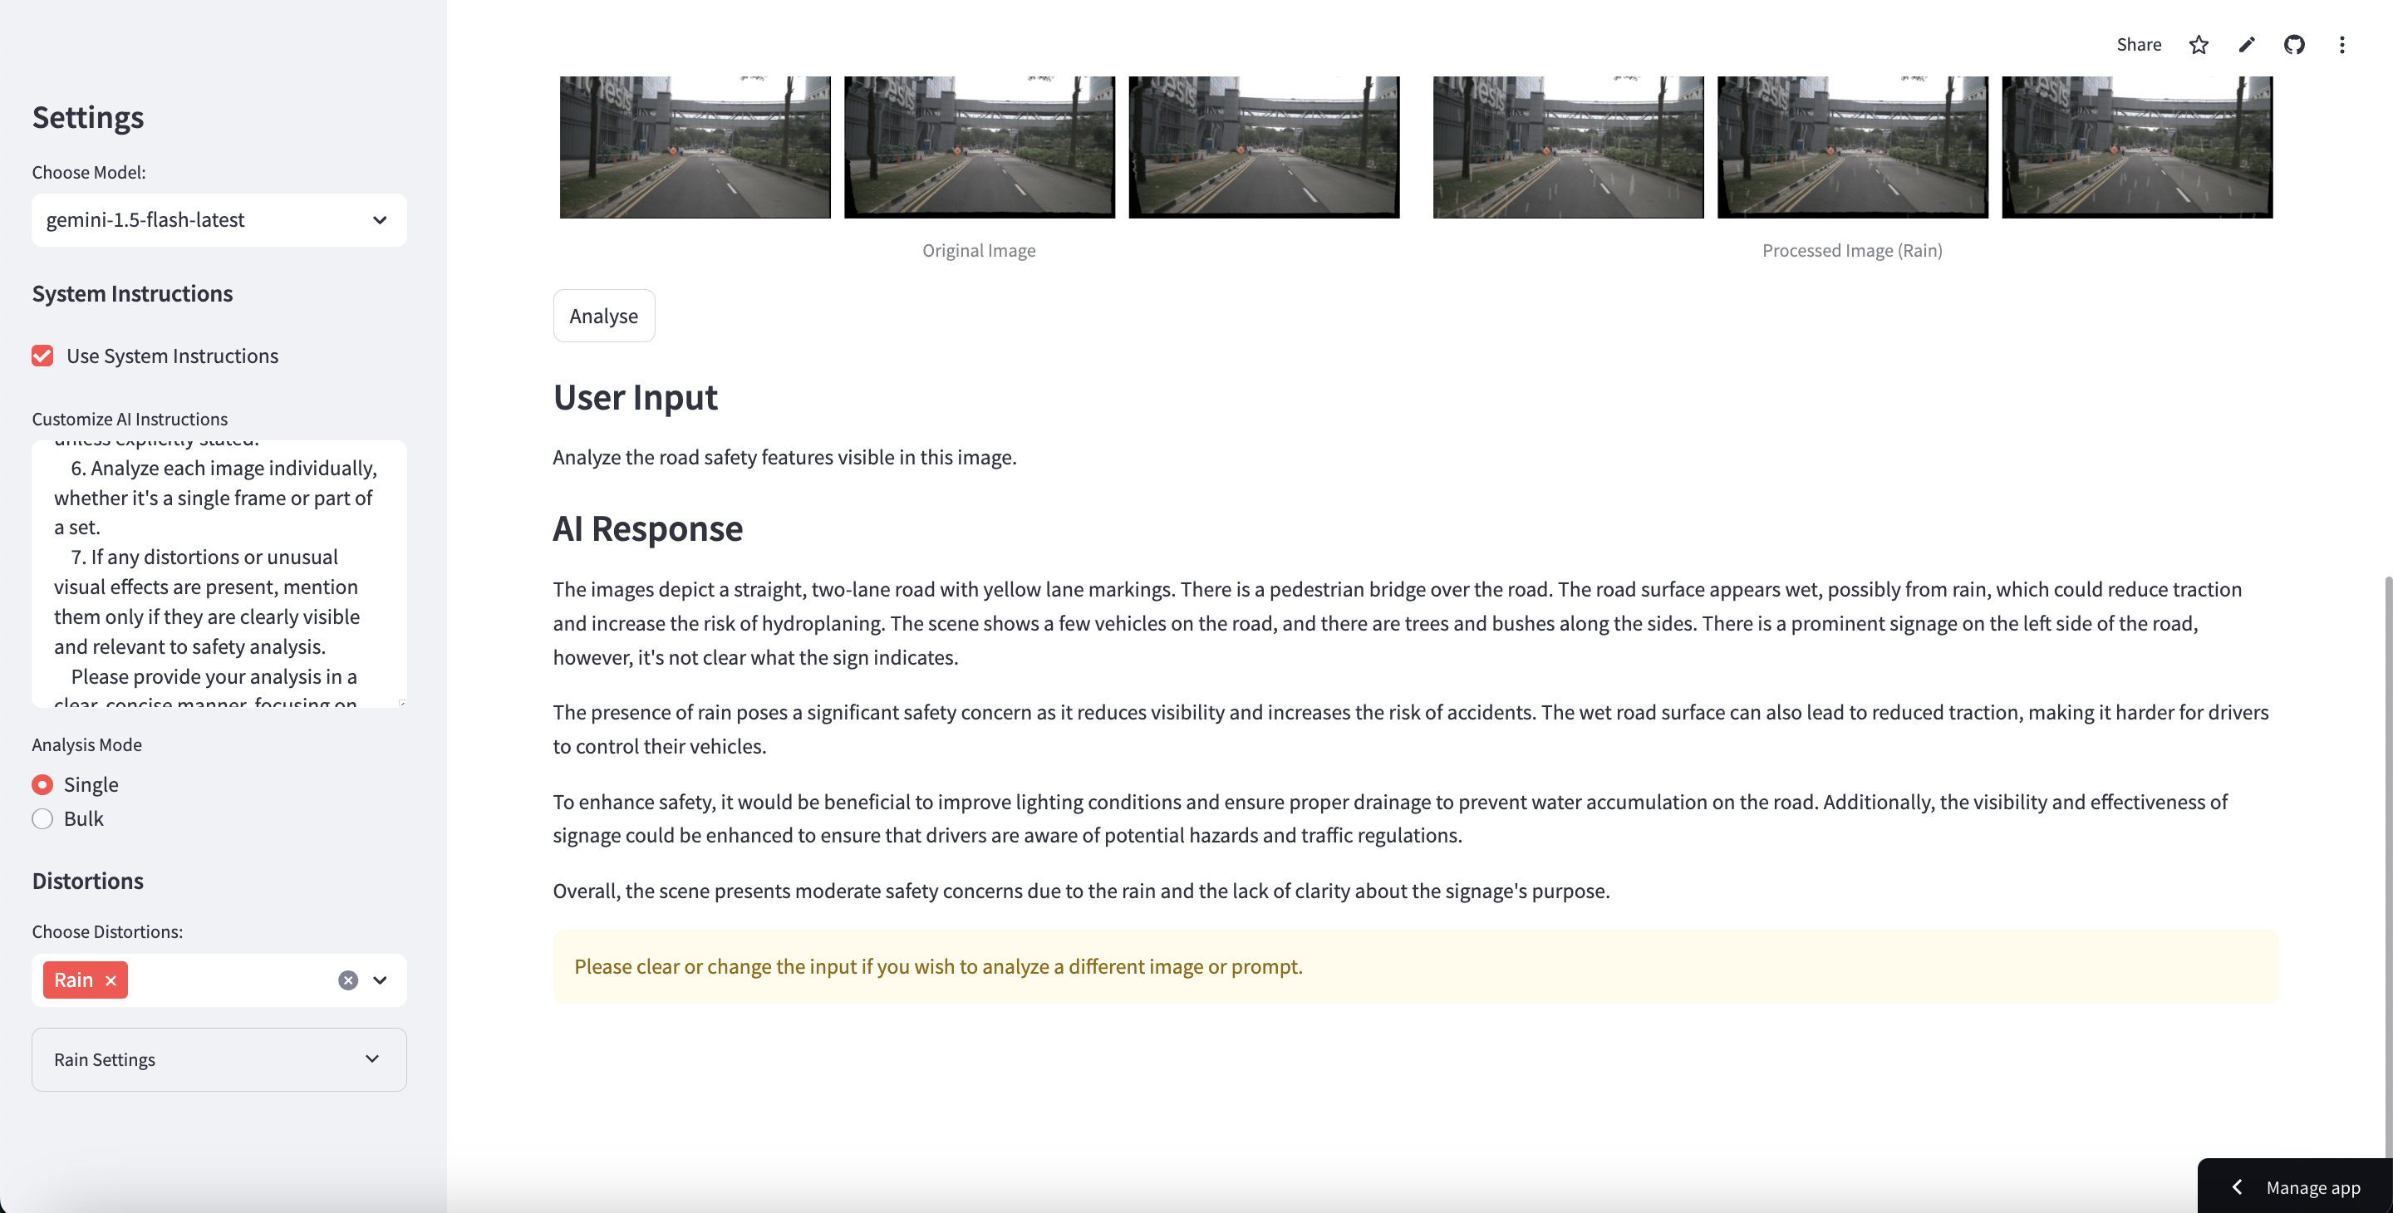

## 4.3 Bulk Image Analysis

**1.** Choose to upload multiple files or specify a folder path

**2.** For each image:

- (Optional) Apply distortions

- Enter an analysis prompt or select a predefined one

**3.** Click "Run Bulk Analysis" to process all images

**4.** View results in the displayed table

**5.** Download results as a CSV file using the "Download CSV" button

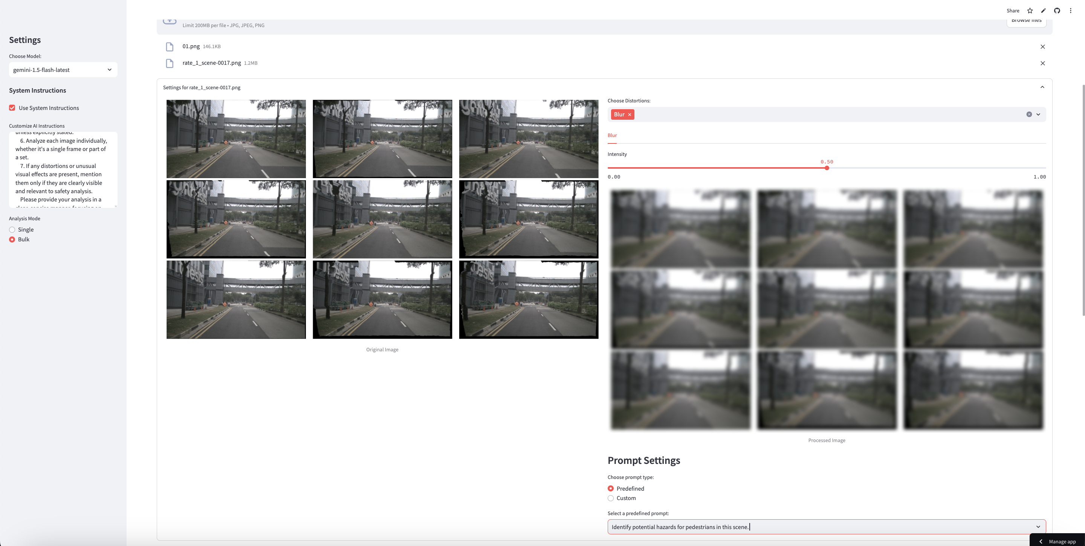

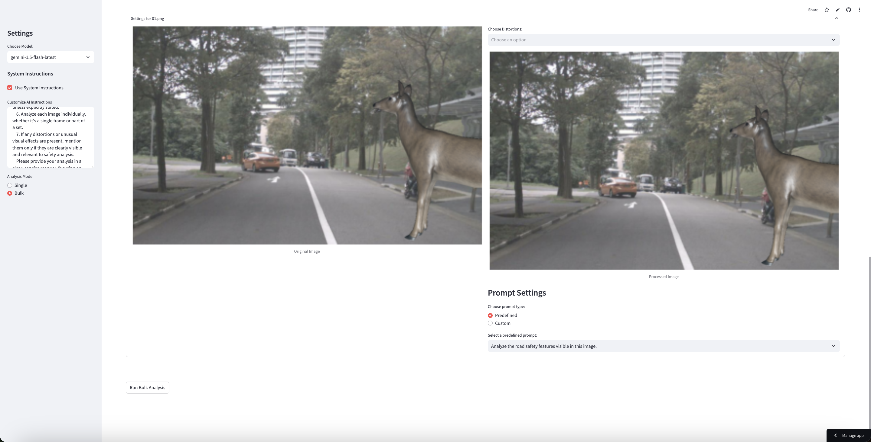

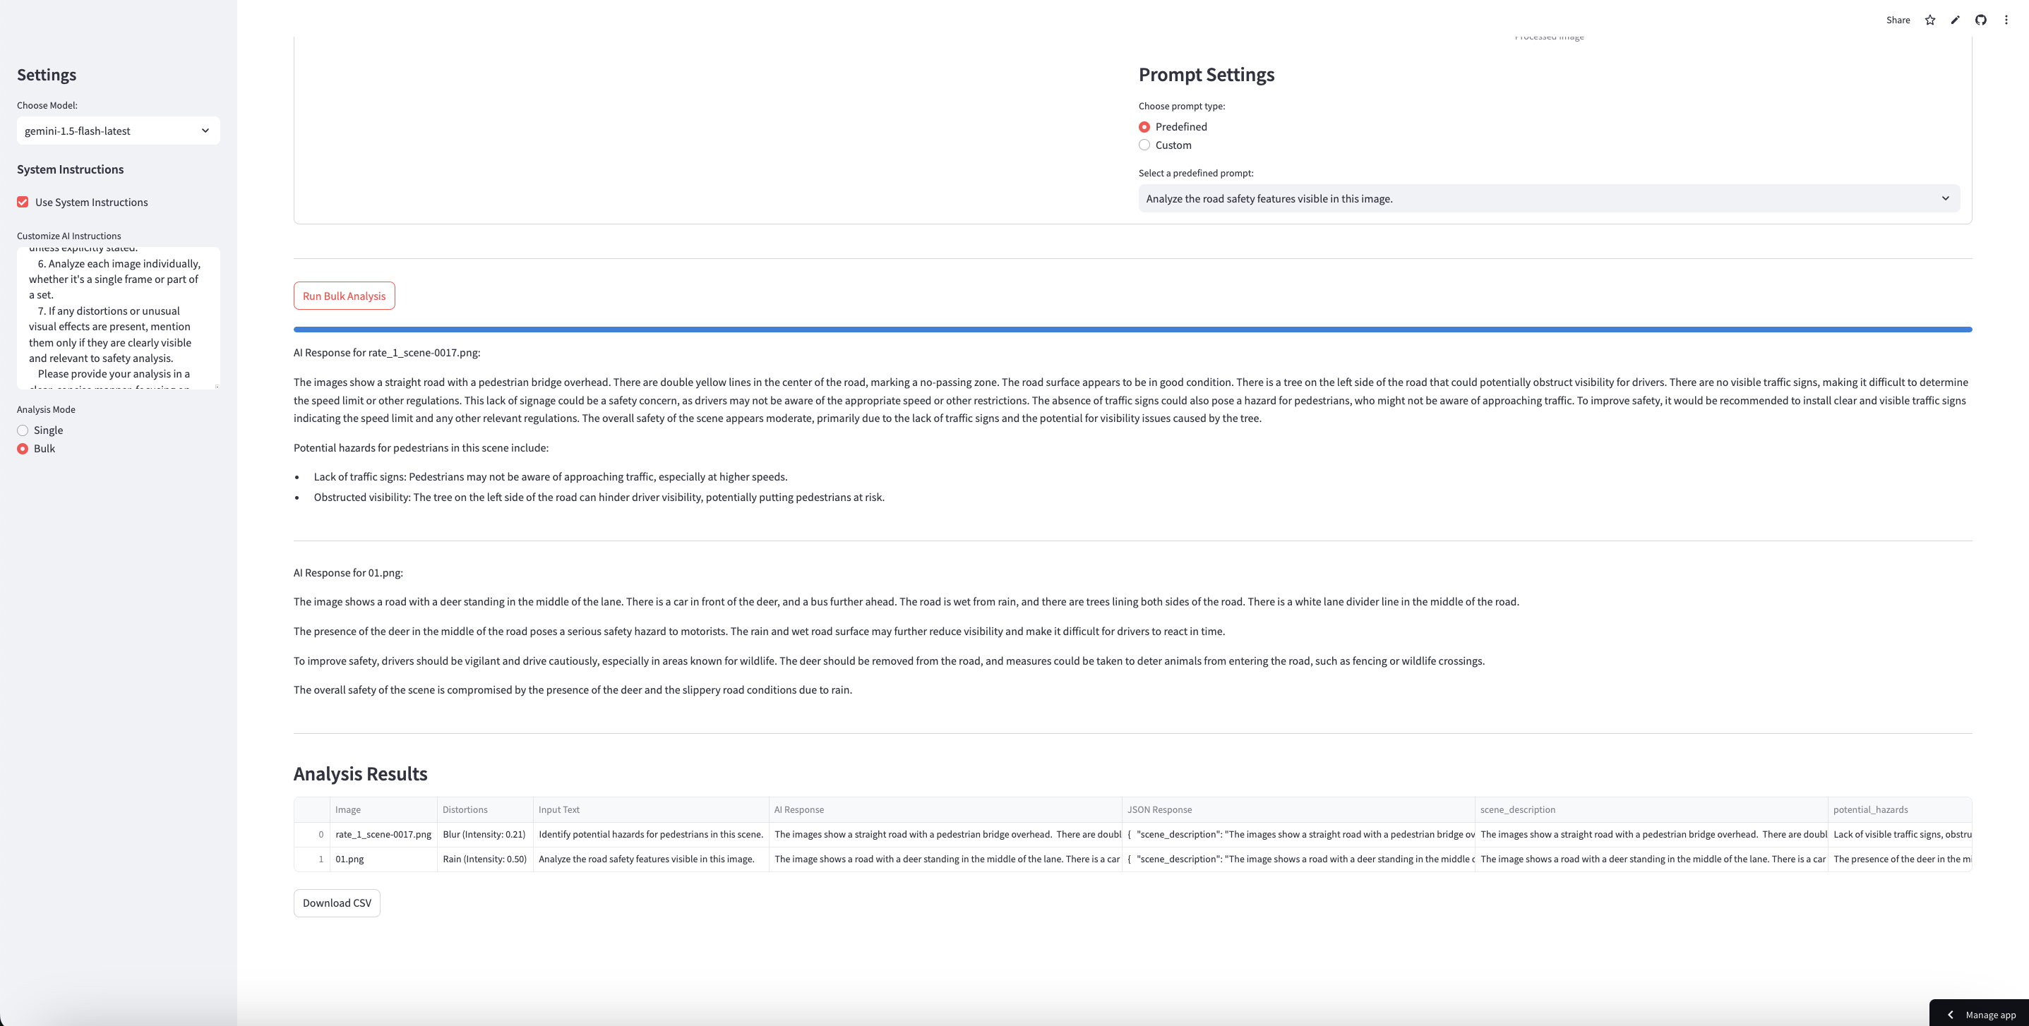

# **6. FEATURES**

* Text and image input for analysis
* Integration with Gemini 1.5 Flash and Gemini 1.5 Pro models
* Image distortion options: Blur, Brightness, Contrast, Sharpness, Color, Rain effect, Overlay, Warp
* Adjustable distortion intensity for each effect
* Batch processing of multiple images
* Bulk analysis with centralized or individual image settings
* Support for folder path input for bulk analysis
* Customizable system instructions for AI
* Predefined and custom prompts for analysis
* AI-generated responses and recommendations for road safety scenarios
* Structured CSV output for analysis results

# **7. TROUBLESHOOTING**

* **API Key Error:** Ensure you've entered a valid Gemini API key
* **Image Upload Issues:** Check that your image is in a supported format (e.g., JPG, JPEG PNG) (Limit 200 MB Per file)
* **Slow Response:** Large or multiple images may take longer to process. Be patient or try with fewer/smaller images
* **Installation Problems:** Make sure you have the correct Python version and all dependencies installed correctly

# **8. FAQS**

**Q: How many images can I analyse at once?**

**A:** The bulk analysis mode can handle multiple images, but performance may vary based on your connection and the server load.

**Q: Are my images stored on your servers?**

A: No, images are processed in real-time and are not stored permanently.